How Can I Help Someone With Severe M.E.?

- Most importantly, people with M.E. need to be believed and respected. Simple as that! If you have read our leaflet “8th August Severe Myalgic Encephalomyelitis Understanding and Remembrance Day” you know how serious M.E. can be. It is an awful illness – show your friend/relative that you know that.
Even severe illness may not be instantly apparent – for example your friend/relative may be able to walk to the toilet, yet be too ill to go out in a wheelchair, watch TV or even sit up in bed for more than a few minutes. They may spend most of their energy on something as basic as eating. They may look remarkably well for half an hour or an hour, but then spend the rest of the day in pain in a darkened room.
Flare up of symptoms after activity or stimuli is a key feature of the illness. The activity may be tiny by healthy standards and stimuli things you probably don't even notice (such as light, movement, or background noise). Here are a few ways to help: shut doors (to reduce noise), use headphones if watching TV nearby, be aware that talking uses energy – ask your friend/relative how long the conversation needs to be and try to stick to that. If they seem particularly energetic, ironically this may be a sign that they are doing too much (and running on adrenaline!) - ask if they need a rest.
Severe Myalgic Encephalomyelitis is very isolating. People with this illness are too ill to work or go to school, and most miss out on all social events and family gatherings. They may be too ill to communicate with friends and family, or to see their doctor (even at home), and they may feel very misunderstood. You can help ease the isolation by including your friend/relative as far as their illness will allow. For example you could take a few pictures of changes in the neighbourhood, video a special event (if they are well enough for TV), send a card, or ask if they want anything when you go to the shop.
Your friend/relative may be too ill to use the phone, or to receive visits. This doesn't mean they don't want contact. You can still send postcards, or where suitable keep in touch with a carer. Many people with M.E. can manage texts more easily than conversations, so this may be a possibility.
Watch the excellent film Voices from the Shadows. Some scenes may be distressing, so watch with care, especially if you have M.E. yourself. http://voicesfromtheshadowsfilm.co.uk/
The 25% group can arrange for information to be sent to any health care or social services professional either directly or through the enquirer – please ask if this might be helpful. We also have an advocacy service for anyone who is struggling with the benefits system.
Research demonstrates an abnormal response to exercise in Myalgic Encephalomyelitis, and the illness can become more severe through attempting to 'push through' the symptoms. Patients need to pace small activities (whether physical or mental) with regular rests. This is extremely challenging, and takes a lot of self-control, as patients want to be getting on with their lives. You can help by being aware of the temptation to do too much, by asking your friend/relative whether they need a rest.
8th August is a day to remember those who have lost their lives to this illness, and those living with it. Please talk to your friends about Myalgic Encephalomyelitis to help spread awareness, post something on Facebook, and maybe share a link to www.25megroup.org . Spend some time reading our website, to inform yourself about the illness.
Donate! The 25% ME Group represents those who are severely affected by this illness, and we will make good use of any donations. You can send a cheque to the address below, or donate online via the donate button on the website.

Thank you for reading this leaflet and for caring about your friend/relative. If you have any more questions or concerns, please do contact us by email at: enquiry@25megroup.org

SEVERE MYALGIC ENCEPHALOMYELITIS
UNDERSTANDING & REMEMBRANCE DAY
8th August
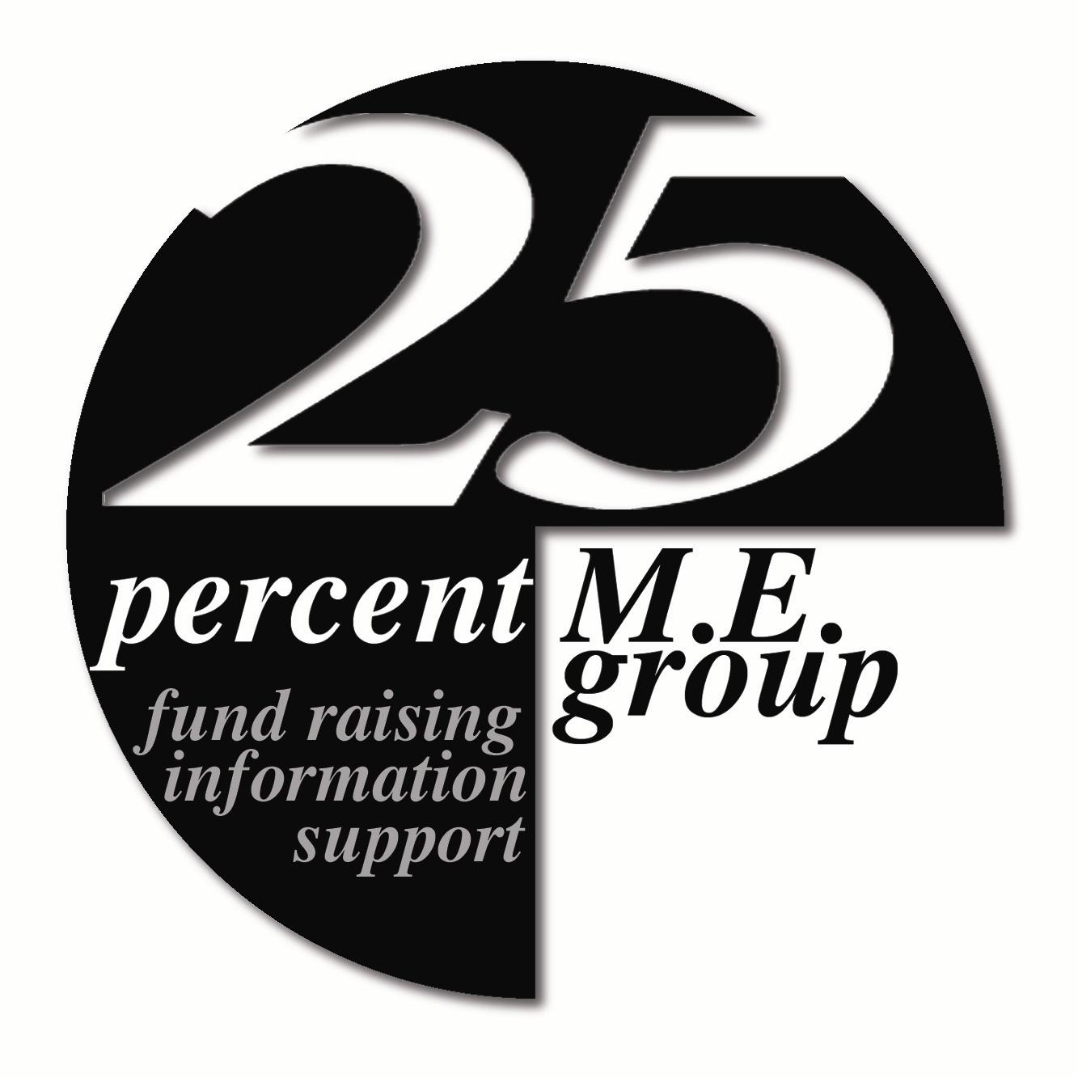
25% M.E. Group
21 Church Street,
TROON, Ayrshire KA10 6HT
Tel: 01292 318611
Advocacy Helpline: 0141 570 2938
See our WebPages on: www.25megroup.org
Charity No: SC034265
PATRON: Dr Byron M Hyde MD
MEDICAL ADVISOR: Dr N Speight MA, MB, B Chir, FRCP, FRCPCH, DCH
SCIENTIFIC ADVISORS: Dr Vance Spence PhD
Prof M Hooper PhD. B.Pharm. C.Chem. MRIC

