UNDERSTANDING & REMEMBRANCE DAY
for
SEVERE MYALGIC ENCEPHALOMYELITIS
8th August

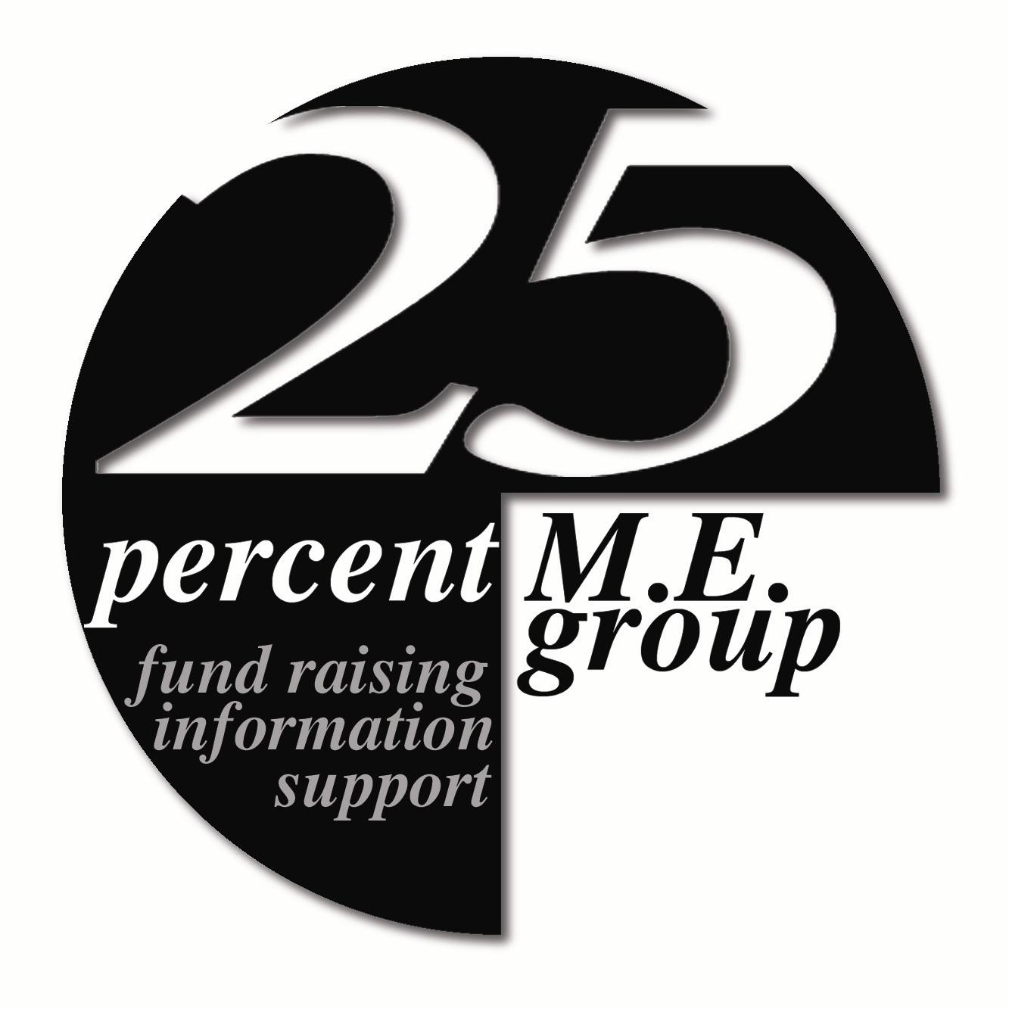

25% M.E. Group
21 Church Street,
TROON, Ayrshire KA10 6HT
Tel: 01292 318611
Advocacy Helpline: 0141 570 2938
See our WebPages on: www.25megroup.org
Charity No: SC034265

PATRON: Dr Byron M Hyde MD
MEDICAL ADVISOR: Dr N Speight MA, MB, B Chir, FRCP, FRCPCH, DCH

SCIENTIFIC ADVISORS: Dr Vance Spence PhD
Prof M Hooper PhD. B.Pharm. C.Chem. MRIC

Why an UNDERSTANDING & REMEMBRANCE DAY?

This day aims to give insight into an illness that is universally misunderstood and to make visible a significant amount of adults and children who have been made invisible by out-of-date untruths.

There is now an urgent necessity to highlight the seriousness of Myalgic Encephalomyelitis and to re-educate the media, Government, medical, healthcare and educational systems, and society as a whole. Hundreds of thousands of children and adults around the world are suffering as a result of ignorance. The immediacy of raising truthful awareness cannot be stressed enough.

Why have an awareness day just for the severely/very severely affected?
These children and adults are gravely ignored and underrepresented. The severity and nature of their illness make it impossible to have contact with loved ones, doctors, or the outside world.

They can no longer pursue their careers, hobbies, or dreams. Many are just simply existing - shallow breathing, not moving, moribund with pain, bed-bound, separate from a world they once knew.

Severe Myalgic Encephalomyelitis brings isolation on many levels such as having a misunderstood disease; being too ill to communicate with friends and family; unable to attend school, work, family gatherings, hospital/doctor appointments; being excluded from biomedical research; feeling cut-off from the whole world; having to fight for the most basic rights such as benefits, care, treatment etc. They can even feel isolated from others with milder forms of the disease – it is as though they have a different illness altogether.

Many are so desperately ill, living in the solitude of a darkened soundproofed room, hidden from view, feeling completely alone. This makes them invisible to the rest of the world. Therefore, 8th August is a day to remember them and to give them a voice. It is a day of global re-education to erase ignorance and to validate every single adult and child with Severe/Very Severe Myalgic Encephalomyelitis.

For all those who have lost their lives to this very serious illness, we can remember them with a promise that we will continue to validate their lives and the disease that cruelly took them away.

What's the significance of 8th August?
This was the birthdate of Sophia Mirza. Sophia was bed-bound with Very Severe Myalgic Encephalomyelitis and was a victim of widespread ignorance and medical abuse. Her doctors couldn't understand why she wasn't getting any better (indicating they had no basic understanding of Myalgic Encephalomyelitis, nor had they kept up-to-date with medical knowledge). Consequently, they did not believe that Myalgic Encephalomyelitis was a physical disease and Sophia was forcibly taken from her bed/home by social workers, police officers and doctors, and taken to a psychiatric facility where she received inappropriate treatment and care. Sophia subsequently died as a result at the age of 32. Her postmortem revealed that she did, in fact, have Severe Myalgic Encephalomyelitis. Unfortunately, this same inexcusable abuse still goes on. You can read Sophia's story here www.sophiaandme.org.uk

How can I help?
Get the facts and accurate information about Severe/Very Severe Myalgic Encephalomyelitis from the following website www.25megroup.

Donate. The 25% ME Group represents those severely affected and they cannot survive without our help. This can be done via the donate button on the home page of the group’s website or by sending a cheque or postal order.

Things need to change for people with severe Myalgic Encephalomyelitis, will you please help and support the UNDERSTANDING & REMEMBRANCE DAY

So how can you help someone with severe M.E.?
People with severe M.E. are asking for no more than other ill people. They need professionals to be aware of the devastating disabling effects of the illness, and its varied symptoms.
Even severe debility may not be instantly apparent – for example a sufferer may be able to walk to the toilet when required, but unable to sit up in bed for more than a few minutes, watch TV or go out even in a wheelchair, and they may find that they expend most of their energy on something as simple as eating.
M.E sufferers are happy to arrange for information to be given to any health care or social services professional, if this will help alleviate the current trend of being met with scepticism and disbelief.
Conspicuous deterioration of symptoms after exertion or stimulus –often apparently trivial– is a key feature of this illness.
There is a body of research demonstrating abnormal response to exercise and many members of the 25% ME Group have only become severely affected after attempting this. It is important to be aware of the danger of steering patients towards an approach that is highly likely to cause more harm than good.

If you have any questions, opinions or general concerns that you wish to be addressed, we are more than happy to hear from you. Should you wish to contact us, then please do so. You can also contact us by e-mail at: enquiry@25megroup.org

Thank you for taking the time to read this leaflet and if you are able to make a donation, we would be most grateful.

Name: ……………………………………………………………………………………………
Address ……………………………………………………………………………………………………….

Post Code:………………………………… Tel No: …………………………………………

